**Covid19 Data Visualizer**

A simple tool to visualize up-to-date SARS-COV-2 information

Data set taken scrapped from : <https://ourworldindata.org/coronavirus-source-data>

Current Bugs Found: not yet

Note: The images below may not look the same as the one in the latest build

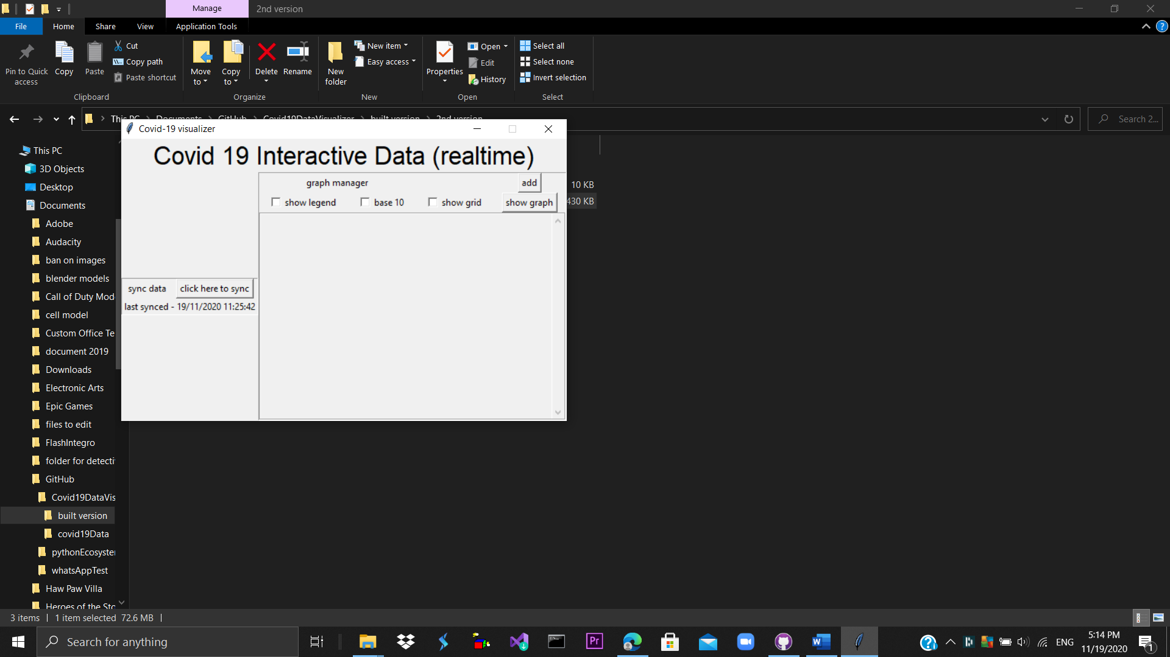

Synchronization of data:



The program checks whether the dataset on the Internet has changed. Usually the dataset will change daily. In order to graph the latest coronavirus statistics. It is advisable to sync the data at least once a day.

Graph manager:



Create graphs out of the data-set.

* Show legend checkbox -> when checked, there will be panel describing the line graph
* 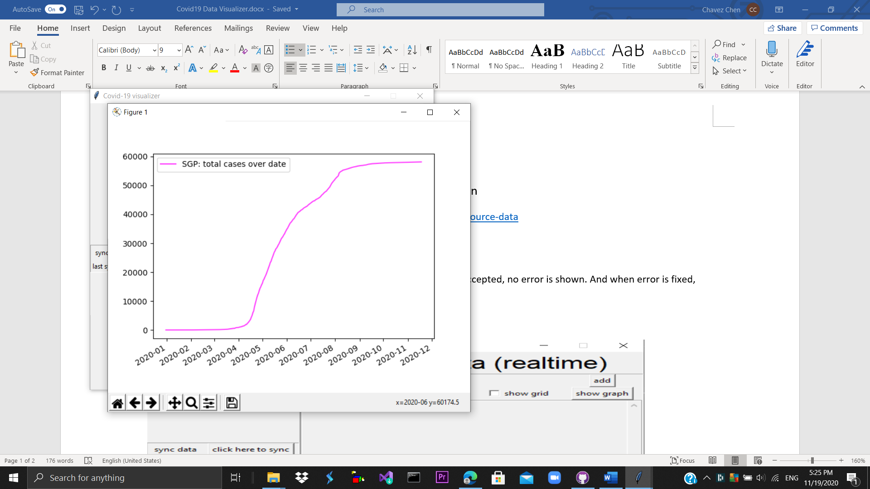
* Base 10 -> ensure the graph display the digits in base 10 (our number system)

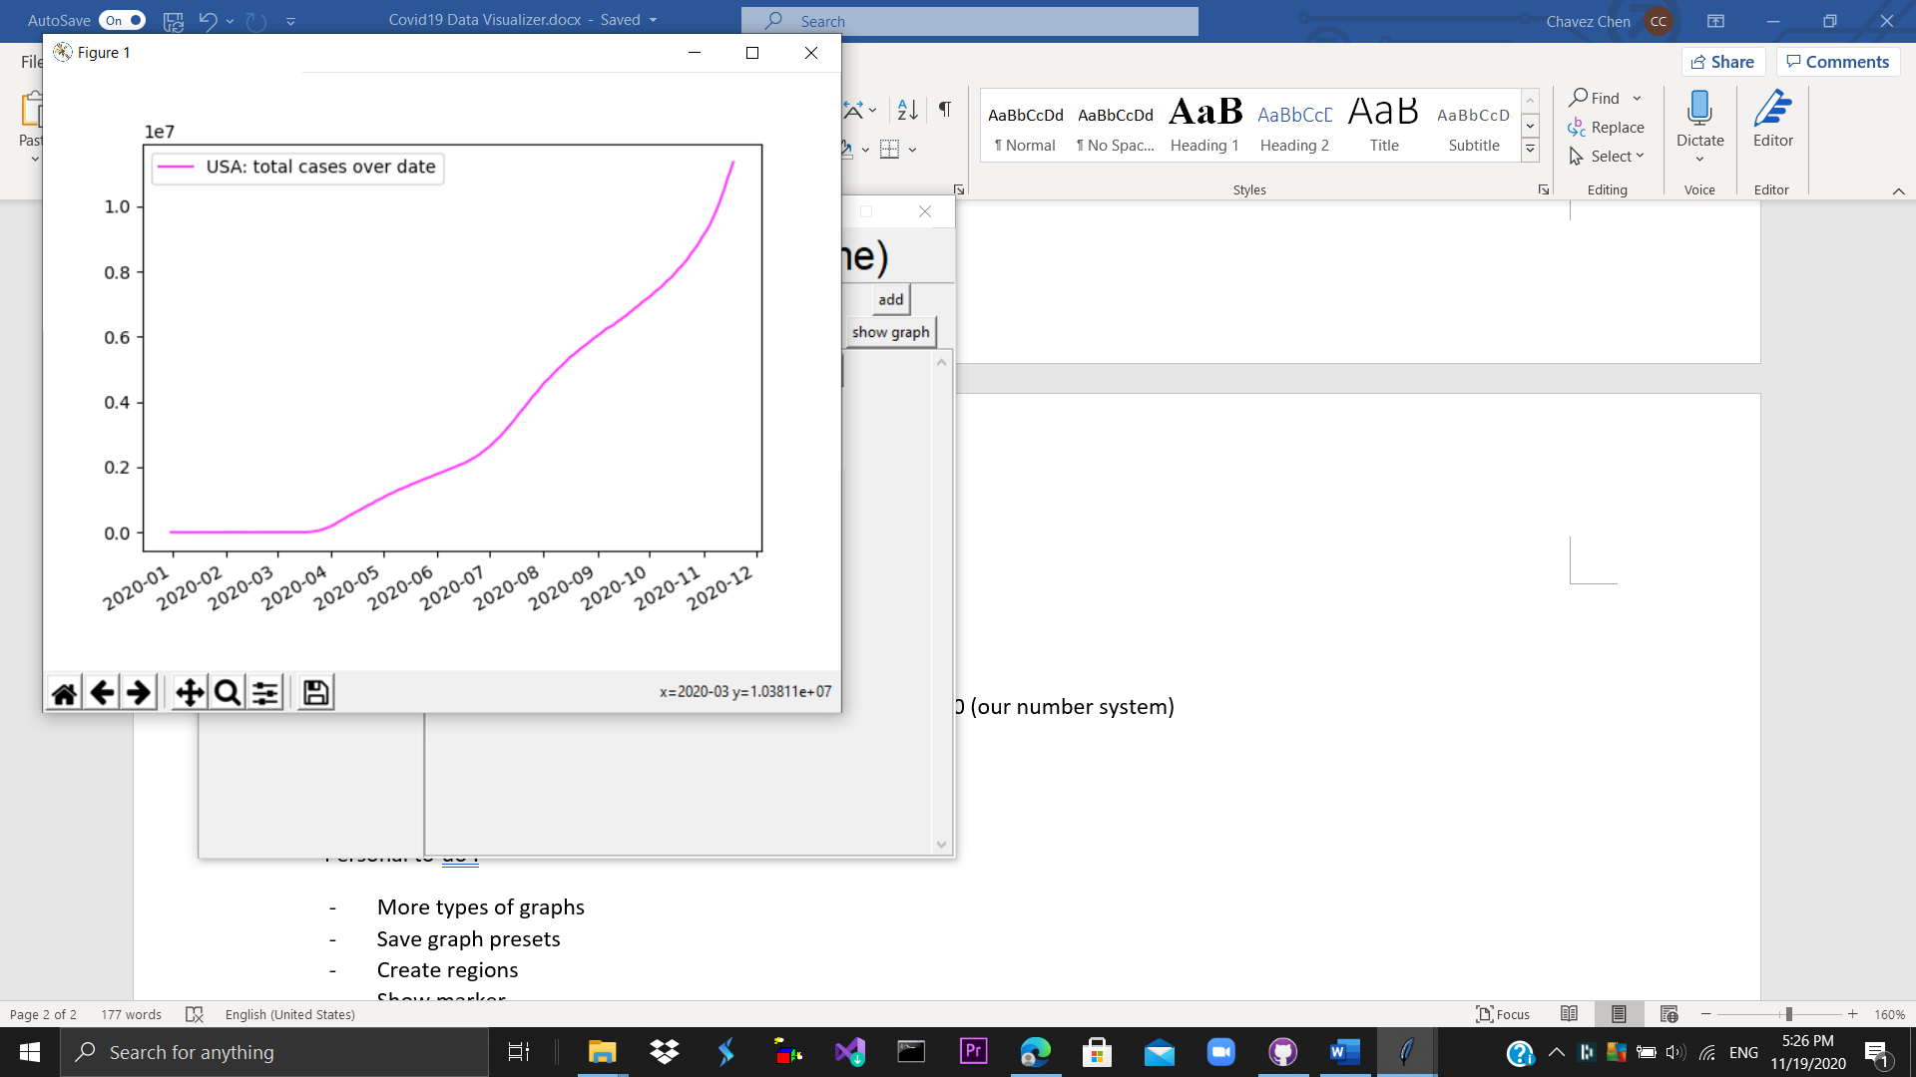<- Base 10 Off 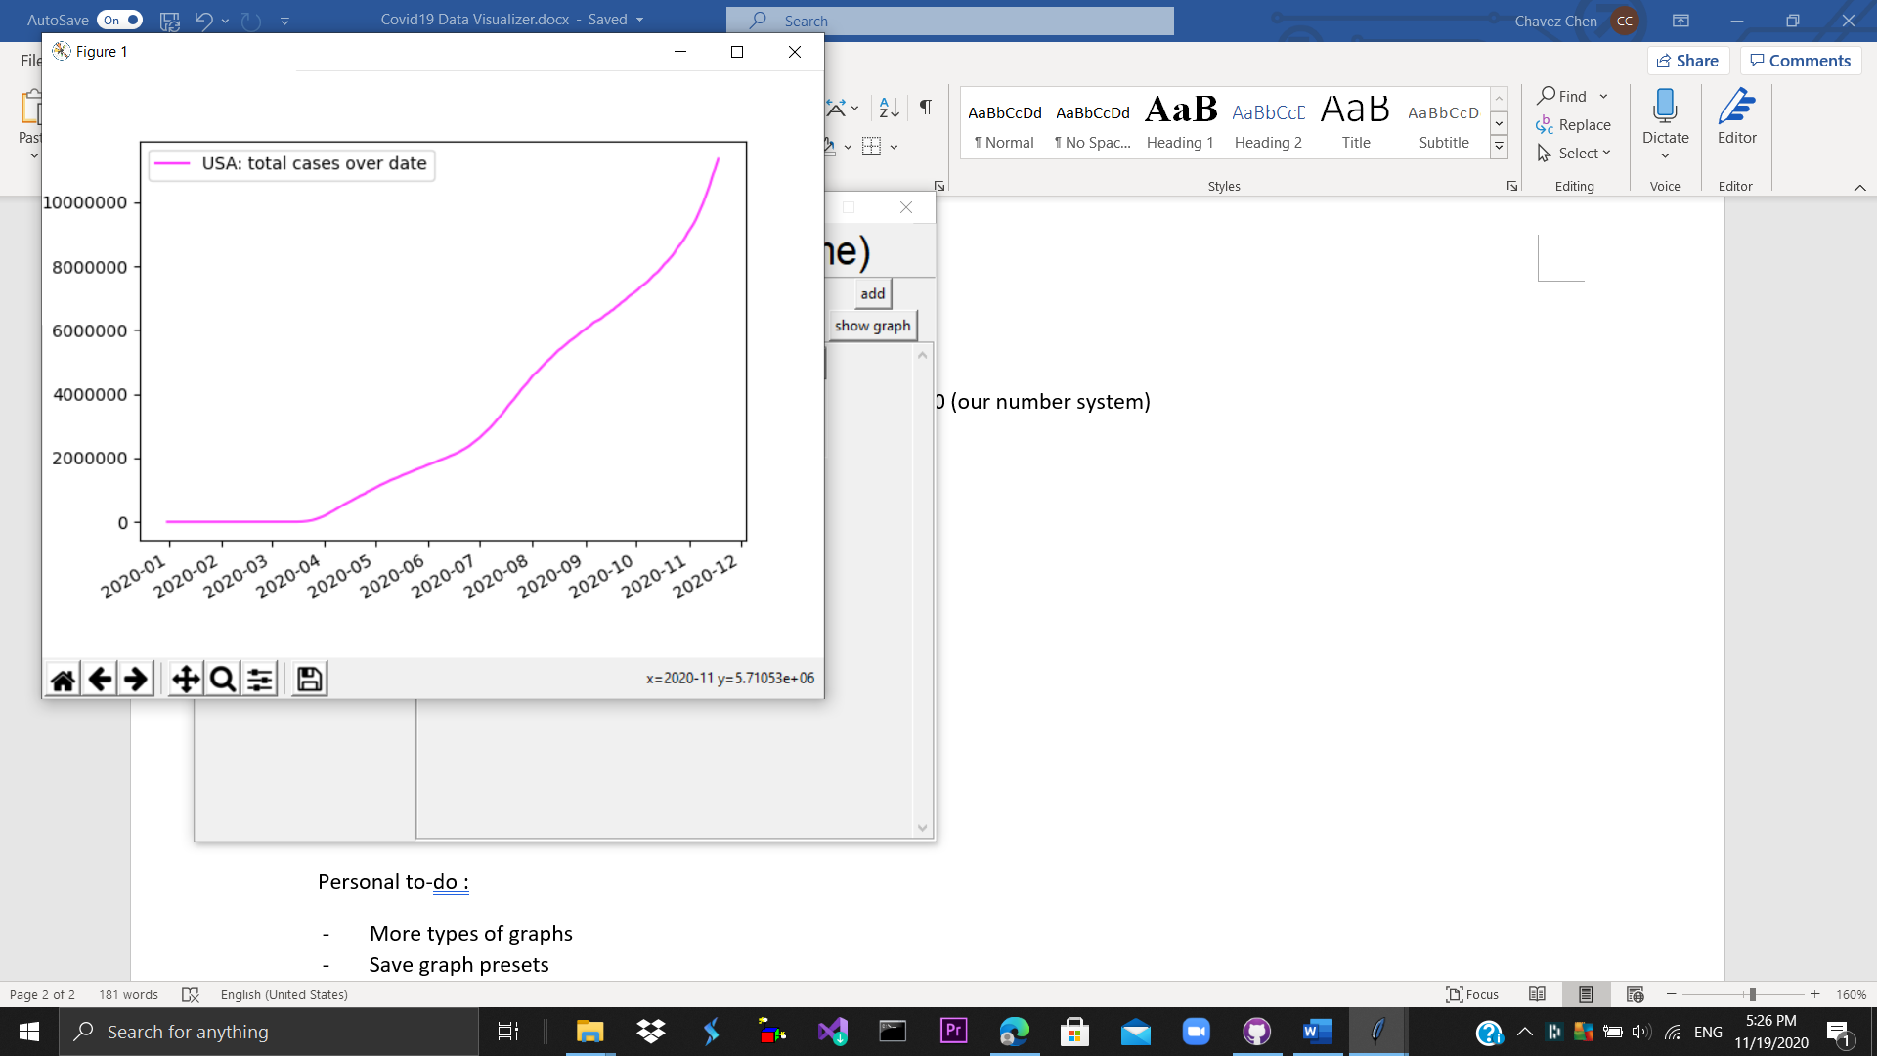 <- Base 10 on

* Show grid -> creates a grid behind the graph

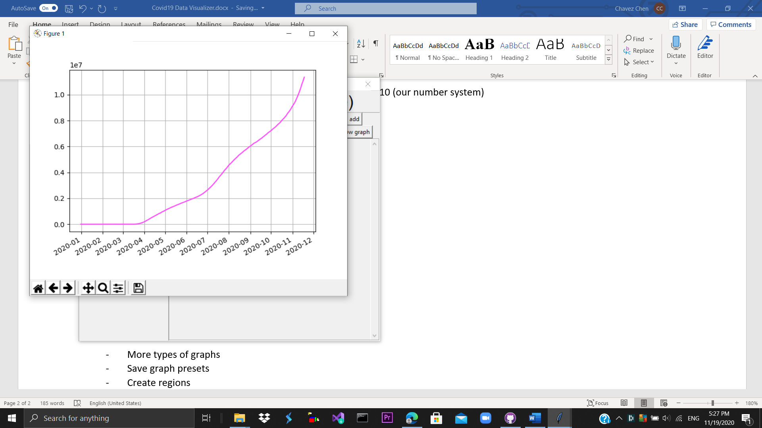

* Show graph -> creates the graph



* Add -> adds lines to the graph

Adding lines to the graph

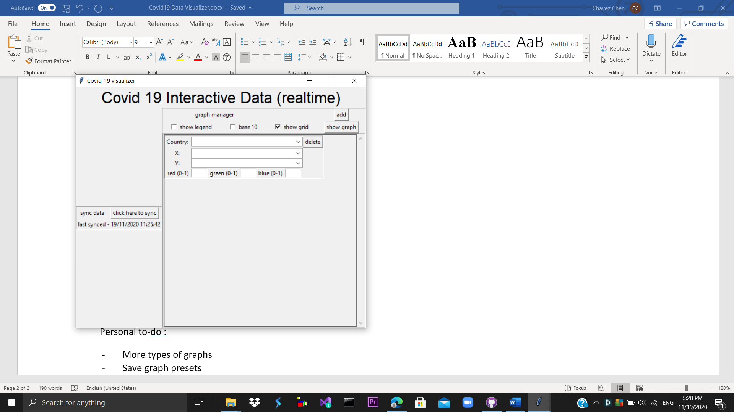

The add button creates a new line for the graph

* Country -> Which creates is the data going to be from (note: country also include Global cases and International cases like Diamond Princess)
* X -> What is the x axis of the graph going to be. (x axis not consistent error -> the x axis has to be same)
* Y -> What is the y axis of the graph going to be. (cannot be a date type)
* Red, green, blue -> the color of the line graph in RGB
* Bar type (Line, Bar) -> The kind of graph to show.

It is possible to have multiple lines in a graph

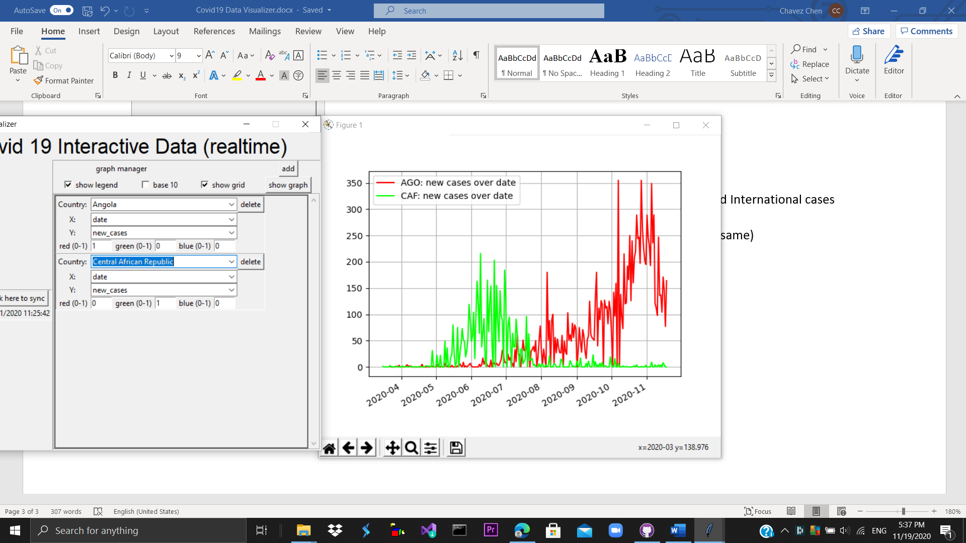

Bar Graphs 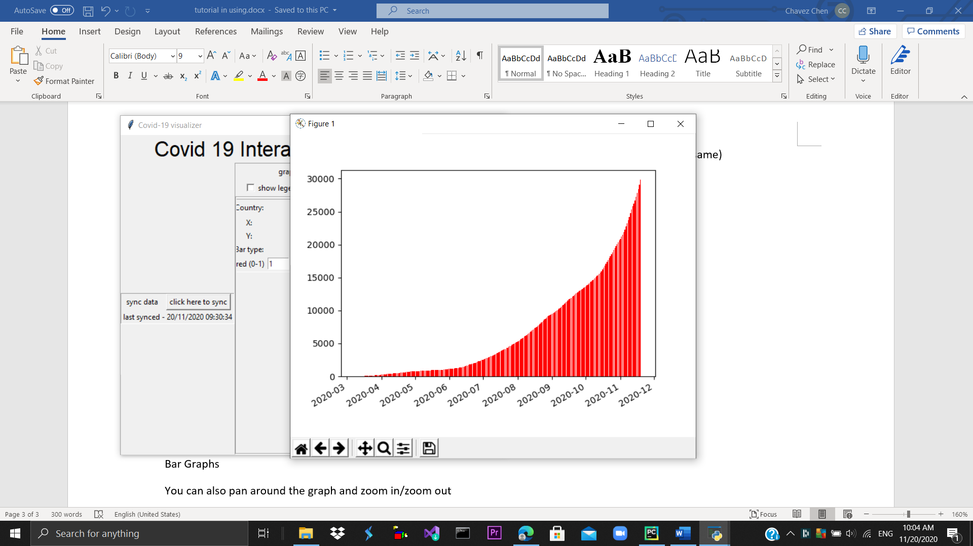

You can also pan around the graph and zoom in/zoom out

Personal to-do :

* Save graph presets - medium
* Create regions - medium

If there are any bugs/suggestions, please fill up this form <https://forms.gle/YqKZgKGdBczrGU138>

Much Thanks

Cheers:

Chavez (Phletic)